IFEDA : COVID-19 Training Policy & requirements
July 2020

By their very nature training courses take place in a confined room, with a number of candidates plus a trainer.
Until further notice attendees on IFEDA training courses and/or workshops must abide by the following:-

All candidates will provide (and shall not attend) without suitable, and sufficient, facemasks* for the duration of the course: the wearing of which is obligatory.
For the full extinguisher course their own basic toolkit as described below.
If a candidate tries to attend a course without facemasks and, where appropriate, the toolkit, they will not be allowed entry and there will be no refund of courses fees.
The provider of the training facilities will provide hand-sanitizer, but you may wish to supply your candidate with their own as well as disinfectant wipes.
*this is over and above the already requested PPE on the course registration form
Full extinguisher course – basic toolkit.**
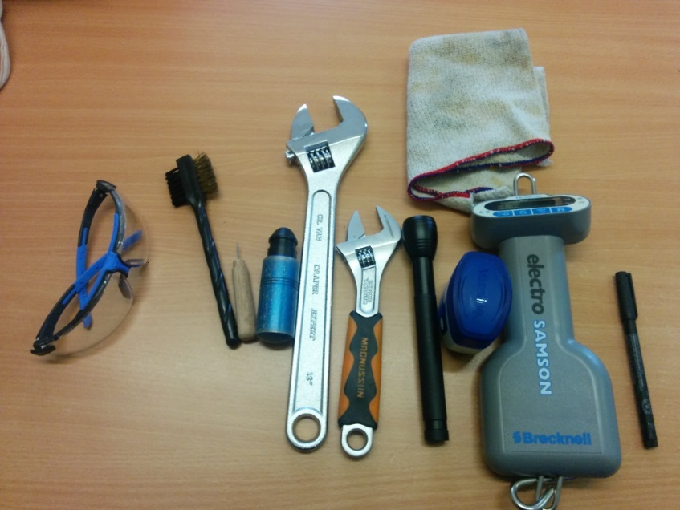

- Safety goggles
- Suitable brush for removing dust and rust
- Gauge pump and/or gauge pin
- Adjustable spanner large enough to remove a CO2 horn
- Adjustable spanner suitable for removing the extinguisher hose
- Torch to check inside a cartridge type unit (and for 5-year check on a stored pressure)
- Petroleum jelly for wet cartridge type units.
- Digital scales able to weigh a full extinguisher or a cartridge
n.b. spring balance types are acceptable, digital luggage/fishing scales circa £10 from Amazon are not***
- Cleaning cloth
- Permanent marker pen for the service label
The above items are available from various sources including IFEDA Members Cherry Parts, TG Products and Checkfire
In addition to the above please provide a basic calculator to work out the weighing percentages.
** there is a comprehensive toolkit listed in the course manual, but this is not required at this stage
*** the inability to give the practical exam’ invigilator a correct answer due to inappropriate scales when weighing the extinguisher and/or cartridge will result in a major loss of points.
The trainer will be able to provide the following:
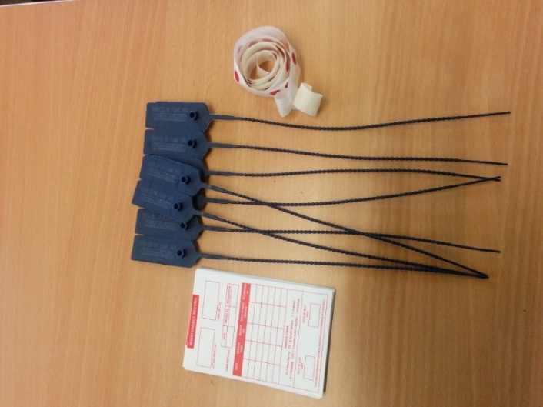

- Service labels
- Tamper tags
- Gauge dots
Full extinguisher course practical sessions. The candidate is not expected to blow down the horn/hose only to go through the motions and to make sure they explain this to the course trainer and exam invigilator.
The practical refilling of a stored pressure is not required by the BS5306-3 syllabus (you must however, know the theoretical sequence) therefore it will be demonstrated by the trainer but candidates need only undertake this element of the course if they wish to.
The instructor will make sure the practical equipment is disinfected on a regular basis, as will work-surfaces and the washing/toilet facilities.
All courses: Until further notice we are unable to provide refreshments e.g. tea/coffee and a buffet lunch: you may wish to provide your own consumables, drinks and mug. Any packaging, used facemasks, tissues, used gloves etc must be taken away by the candidate at the end of each day. mug.
Pens and paper will be supplied but you may wish to supply your own.
Where appropriate, course numbers will be reduced to allow candidates to practice and adhere to, where possible, the social distancing requirements.
If a candidate displays any symptoms of COVID-19 during a course e.g. high temperature, persistent cough, stomach cramps, diarrhoea, sickness issues, loss of taste and/or smell they must leave the course immediately and report this to their line manager.
Equally, if a candidate starts to display any of the above Covid-19 symptoms within 7 days of attending a course the IFEDA office MUST be informed immediately.

IFEDA will do everything it can to mitigate the transmission of Covid-19 but it must be understood that attendance on any of our courses or workshops is at the client's/candidate's own risk.
QC41 issue 1

